*The following table compares and contrasts the major types of cells with one another. Complete the table with the terms provided below.*

|  |  |  |
| --- | --- | --- |
| **Prokaryotic** | **Both** | **Eukaryotic** |
|  |  |  |

|  |  |  |  |  |
| --- | --- | --- | --- | --- |
| Nucleus | Plants | DNA | Protists | Cell membrane |
| Animals | Bacteria | Fungi | Ribosomes |  |

*The following table compares and contrasts plant and animal (both eukaryotic) cells with one another. Complete the table with the terms provided below.*

|  |  |  |
| --- | --- | --- |
| **Plant** | **Both** | **Animal** |
|  |  |  |

|  |  |  |  |  |
| --- | --- | --- | --- | --- |
| Nucleus | Smooth ER | Central vacuole | Rough ER | Cell membrane |
| Golgi | Chloroplasts | Lysosome | Ribosomes | Cell wall |
| Mitochondria | DNA |  |  |  |

**Draw** a flowchart for the pathway within the cell that would be needed for each of the following cellular activities:

* Export proteins out of the cell
* Production of ATP in a plant cell
* Production of ATP in an animal cell
* Digestion of a bacteria enclosed in a food vacuole
* **Label** the image of the fluid mosaic model with the following terms.

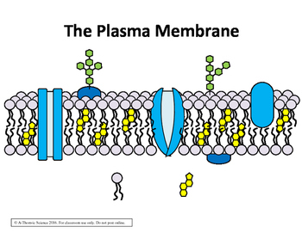

|  |  |  |  |
| --- | --- | --- | --- |
| Carbohydrate chain | Lipid bilayer | Phospholipid | Hydrophobic |
| Membrane protein | Extracellular space (outside cell) | Hydrophilic | Cytoplasm |

* **Discuss** the properties of one phospholipid and **explain** how these properties enable the formation of the lipid bilayer (shown above).
* **Predict** how each of the following components of a cell membrane enable the cell to choose what enters or exits the cell.
  + Phospholipid bilayer
  + Carbohydrate chains on a glycoprotein
  + Transport protein
* **Draw** a model that shows the distribution of water and solute as well as the direction that water will flow for each of the following scenarios:
  + A cell that is hypertonic to the solution around it
  + A solution that is hypertonic to a cell
  + A cell that is isotonically balanced with the solution around it
* **Identify** the structure in a plant cell that prevents them from bursting in a hypotonic solution.
  + How would an animal cell have reacted in this same situation? **Explain**.
  + What organelle are many single-celled organisms equipped with to prevent this from occurring?
* **Create** a table in which you organize the following terms/phrases to demonstrate your understanding about the types of cellular transport we have learned about.

|  |  |  |
| --- | --- | --- |
| Down concentration gradient | Membrane protein | Through lipid bilayer |
| Active transport | Up concentration gradient | No membrane protein |
| Glucose transport into muscle cells | Facilitated diffusion | Diffusion |
| Oxygen/carbon dioxide exchange in lungs | Small/uncharged molecules | Sodium-Potassium pump in neuron |

* Ordinarily, water moves via osmosis (a type of diffusion) because it is very small, but it is a polar molecule, so it doesn’t move across the lipid bilayer very rapidly. Which mechanism of transport would be required to allow water to flow at a faster rate down its concentration gradient? **Explain**.
* **Explain** how the composition of organelles would differ in the following cell types?
  1. A cell that transports substances throughout the body
  2. A cell that must consistently break down substances that are engulfed as food
  3. A cell that is responsible for movement of the body
  4. A cell that secretes proteins
  5. A cell that secretes lipid-based hormones
  6. A cell that breaks down toxic substances for the body
* For each of the model cells below, **calculate** their surface area, volume, and surface area to volume ratio.

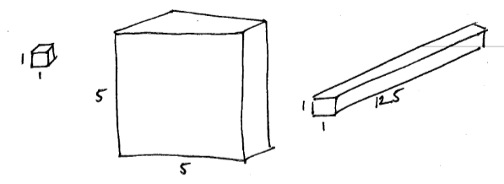

|  |  |  |  |
| --- | --- | --- | --- |
|  | A | B | C |
| Surface Area |  |  |  |
| Volume |  |  |  |
| SA:V ratio |  |  |  |

* **Explain** why although cubes B and C have the same volume, diffusion progresses faster in cube C.
* How does a specialized cell membrane structure for each of the following cell types allow them to perform their function?

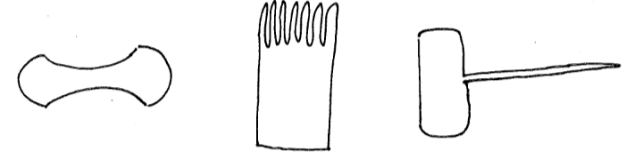

|  |  |  |
| --- | --- | --- |
| Erythrocyte (Red blood cell) | Simple columnar epithelial cell | Root hair cell |